Supplementary material file 4：Audiograms for the twelve Chinese families with non-syndromic deafness.

Audiograms(ASSR) for NT-41～44,47(A) Audiograms for NT-45,46,48,51,52(B)
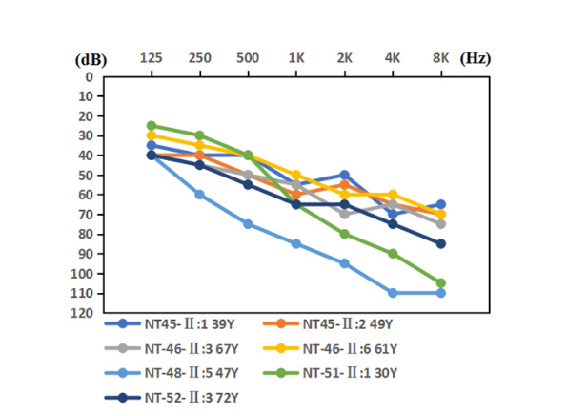
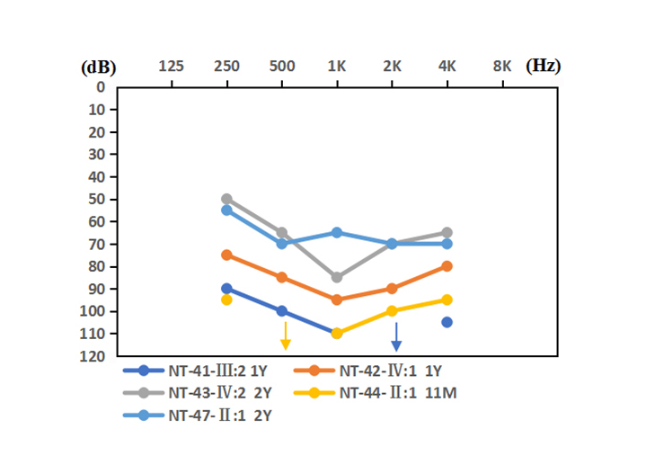
B
A

Audiograms for NT-49(C) Audiograms for NT-50(D)
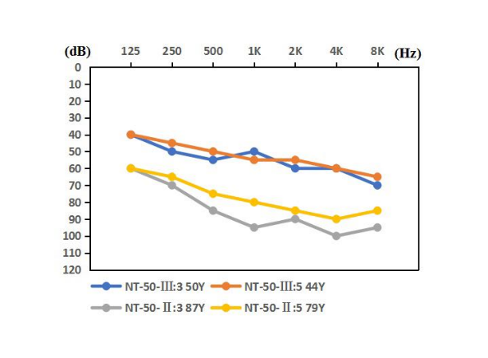
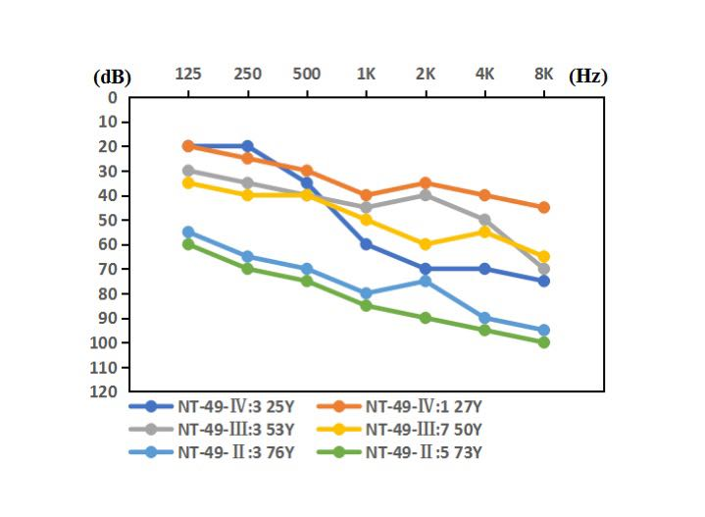
D
C

